**WEEK - 1**

**DATE : 31-03-2022**

**Q) Different types of DBMS Softwares.**

|  |  |  |  |  |  |  |  |  |  |  |
| --- | --- | --- | --- | --- | --- | --- | --- | --- | --- | --- |
| **Sno** | **Name** | **Features** | **Source** | **Developed**  **company** | **Version** | **Usage of**  **Software** | **Applications** | **Supported**  **OS** | **Developed**  **Year** | **Data model** |
| **1** | **PostgreSQL** | **Table inheritance** | **open source** | **PostgreSQL Global Development Group** | **14.0** | **primary data store for many web, mobile** | **Uber**  **Netflix**  **Instagram**  **Spotify** | **macOS Windows Linux FreeBSD** | **1996** | **relational model** |
| **2** | **MySQL** | **multi-version transaction support** | **open-source** | **Oracle Corporation** | **8.0.28** | **data warehousing, e-commerce, and logging** | **Airbnb**  **Netflix**  **Pinterest**  **Amazon** | **Linux**  **Solaris**  **macOS**  **Windows FreeBSD** | **1995** | **Relational model** |
| **3** | **Microsoft SQL Server** | **transaction processing, business intelligence** | **commercial** | **Microsoft** | **15.0** | **to manage multiple databases** | **Bank of America**  **DELL** | **Linux Microsoft Windows** | **1989** | **relational model** |
| **4** | **Oracle** | **Secured,**  **Less space,**  **Less cpu time** | **Commercial** | **Oracle** | **19c** | **Banking** | **LinkedIn**  **ebay** | **Windows**  **Linux**  **Mac os** | **1979** | **Multi model** |
| **5** | **Amazon RDS** | **Easy to install,**  **Inbuilt data**  **Restoration** | **Open source** | **Amazon** | **13.4** | **Shopping** | **Amazon.**  **CRED.** | **Windows**  **Linux**  **Mac os** | **2009** | **Relational** |
| **6** | **Tera Data** | **Data import,**  **Export easy,**  **Distributed**  **Data easy** | **Commercial** | **Tera data** | **16.20** | **Manage Large**  **data** | **Morgan Stanley**  **JPMorgan Chase** | **Windows**  **Linux**  **Mac os** | **1979** | **Multiple** |
| **7** | **IBM Db2** | **table partitioning high availability disaster recovery** | **Commercial** | **IBM** | **11.5.7** | **management of both structured and unstructured data** | **Fiserv** | **Linux**  **Unix**  **windows** | **1983** | **relational** |

**WEEK - 2**

**DATE : 07-04-2022**

**Q) Different types of MYSQL Commands**

* **MYSQL COMMANDS ARE CASE INSENSITIVE**

**MYSQL COMMANDS:**

* **show databases;**

**Usage : this command is used to view the databases present in the MYSQL software.**

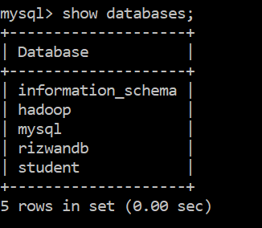

* **create database database_name;**

**Usage : this commad is used to create a database with the name we want .**

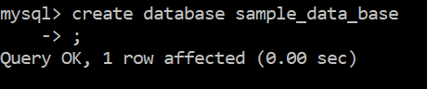

* **use database_name;**

**Usage : the database we want to use is selected with this commad**

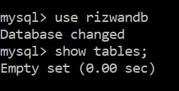

* **create table table_name( col1_name datatype(size), col2_name datatype(size),..));**

**Usage : this commad is used to create table with a particular name and give the coloum names with particular datatype and size**



* **show tables;**

**Usage : this command is used view all the tables in the particular database which we have selected previously**

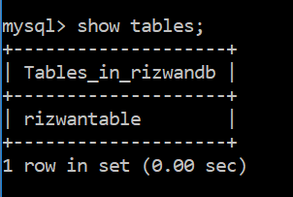

* **desc table_name;**

**Usage : this command is used to view the description of table like fields created and their datatyes**

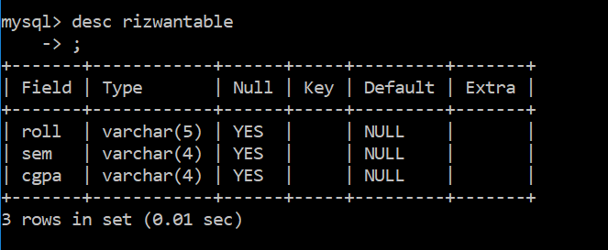

* **insert into table_name values(val1,val2,val3 ,……..);**

**Usage : This command is used to insert values into the rows of tables**

**insert.PNG**

* **select * from table_name;**

**Usage: This command is used to show all the data present in the table**

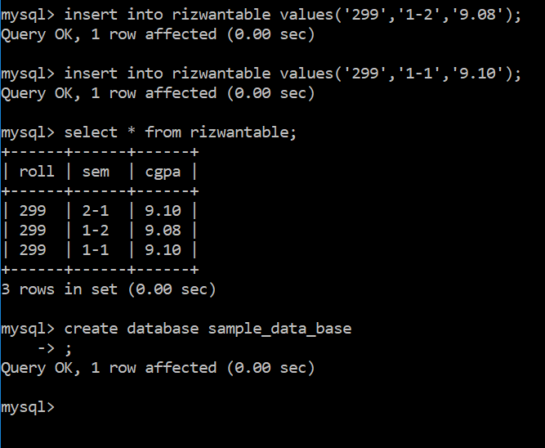

**Q) Different types of datatypes in MYSQL:**

|  |  |
| --- | --- |
| **Data type** | **Description** |
| 1. Varchar(size) | It allows any character from the keyboard with gaps allow also…. |
| 1. Binary(size) | It is equal to the varchar( ), but it stores byte strings…. |
| 1. Varbinary(size) | It is same as varchar() but, it stores binary byte strings. |
| 1. Text(size) | Holds a string with max-limit of 65,535 bytes. |
| 1. Tinytext(size) | Holds a string with max-limit of characters from 0 to 255. |
| 1. Blob(size) | Binary large objects holds upto 65,535 bytes of data. |
| 1. Longtext(size) | Holds a string of max-limit 4,294,967,295 characters. |
| 1. Bit(size) | A bit value type, the number of bits per value specified and max-limit holds from 1 to 64. |
| 1. Bool/Boolean | 0 is considered as false, non-zero values as True. |
| 1. Int/integer | A medium integer of signed range from -2147483648 to 2147483648. Unsigned range from 0 to 4294967295. |
| 1. Float(p) | A floating point number.  P is 0 to 24 i.e; Flaot value.  P is 25 to 53 i.e; double value |
| 1. Date | Format : yyyy – mm – dd , range :  1000-01-01 to 9999-12-31. |
| 1. Datetime(fsp) | Format : yyyy—mm—dd  Hh:mm:ss |
| 1. Time(fsp) | Format: hh : mm : ss  Range : -838:59:59 to 838:59:59. |
| 1. year | A 4 digit format is allowed from 1901 to 2155 and 0000 also. |

**Example of some datatypes from above table :**

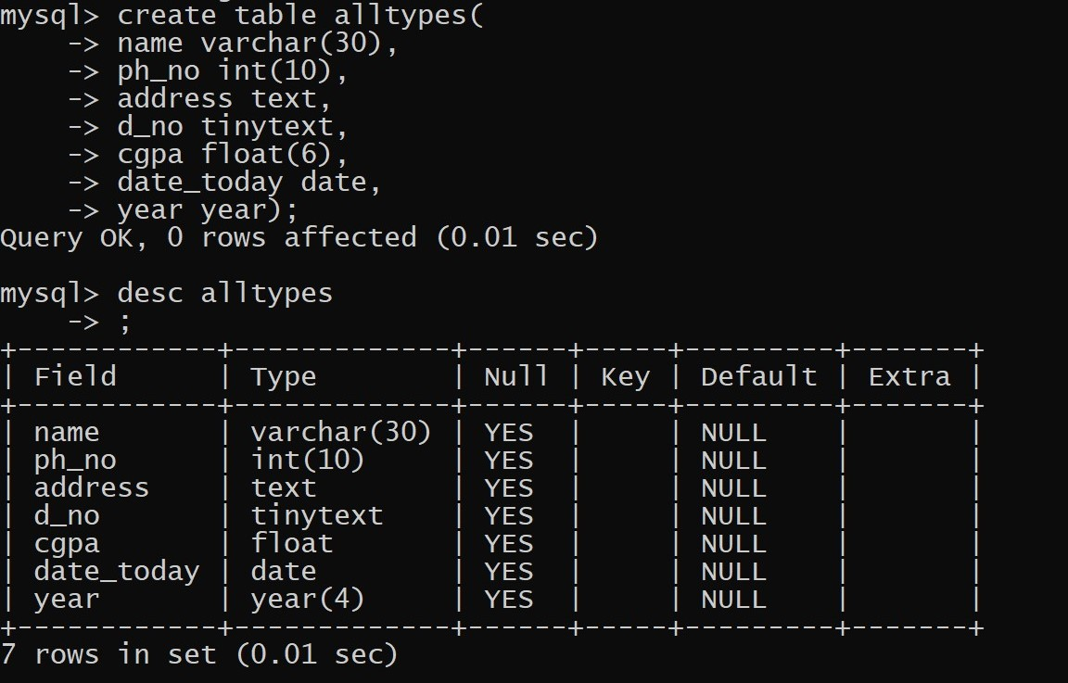

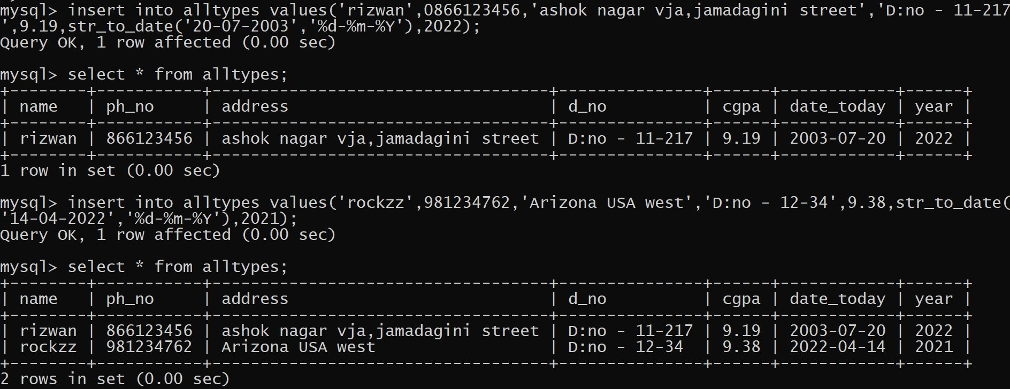

**WEEK - 3**

**DATE : 31-03-2022**

**DDL COMMANDS (Data Definition Language ):**

**Alter:**

**mysql> alter table rizwantable add ph_no int(10) after roll;**

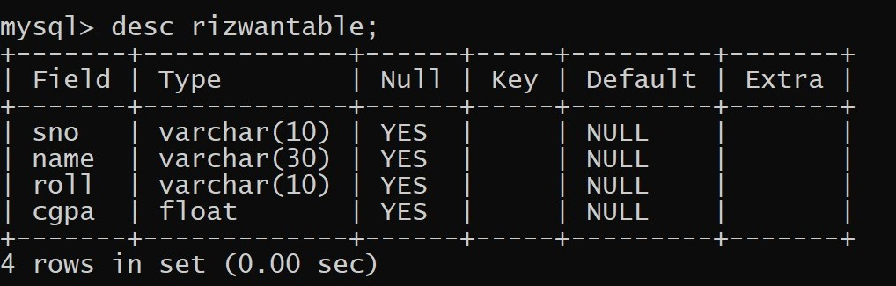

**mysql> alter table rizwantable add address text after ph_no;**

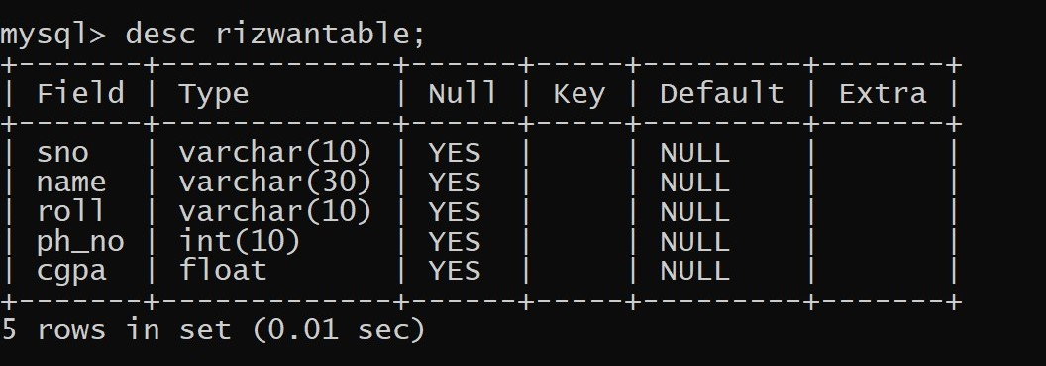

**mysql> alter table rizwantable add address text after ph_no;**

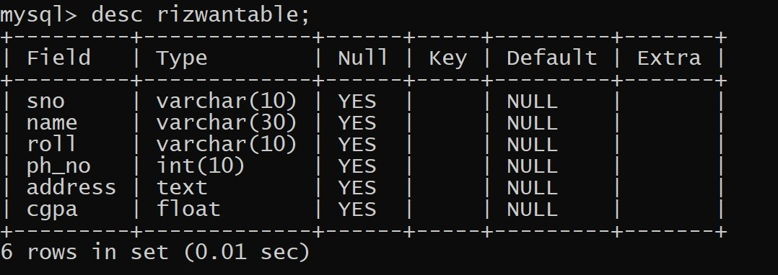

**mysql> alter table rizwantable modify cgpa float(6);**

**mysql> alter table rizwantable change column ph_no phone int(10);**

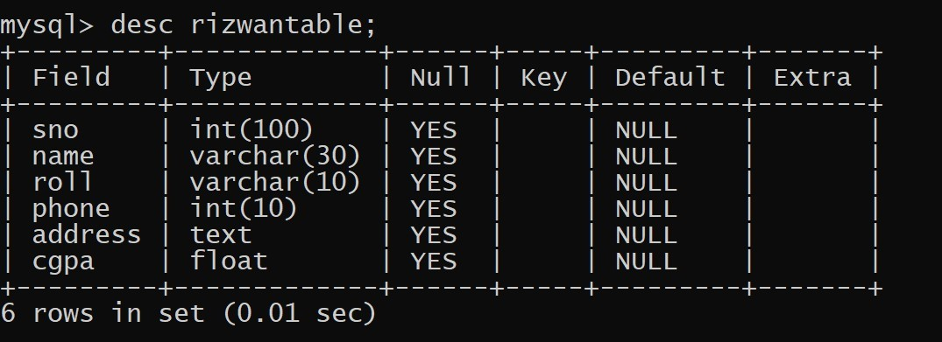

**mysql> alter table rizwantable add street tinytext;**

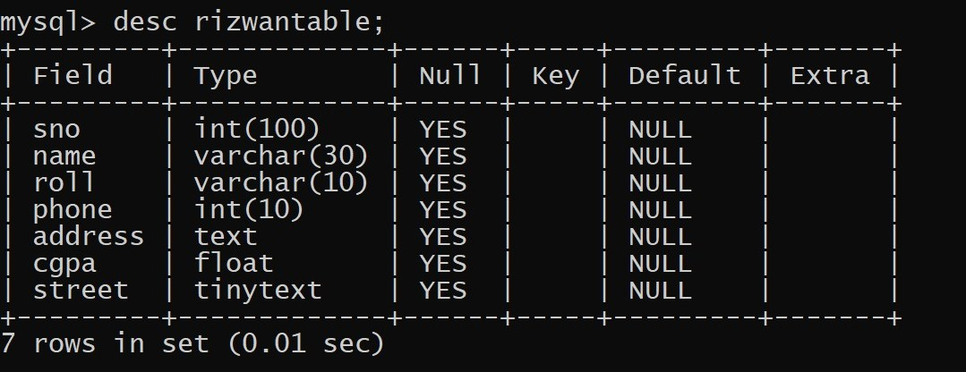

**mysql> alter table rizwantable drop column street;**

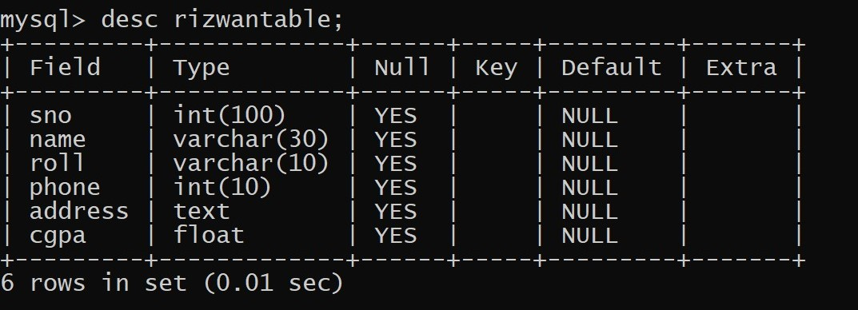

**Modify :**

**mysql> alter table rizwantable modify sno int(10);**

**mysql> alter table rizwantable change column phone ph_no int(10);**

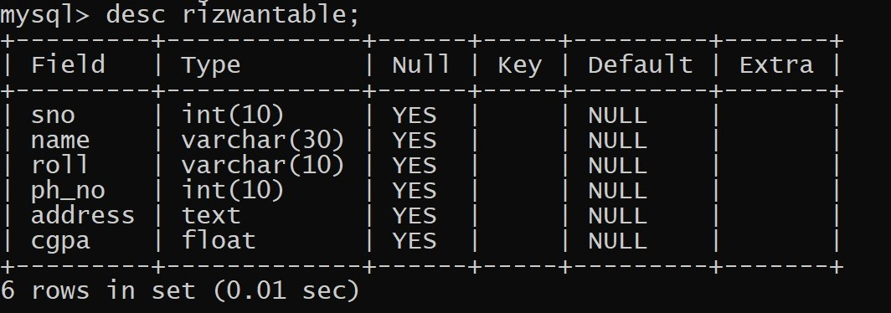

**Drop :**

**mysql> drop table faketable;**

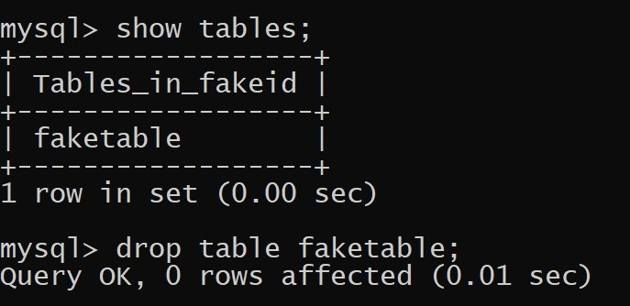

**mysql> drop database fakeid;**

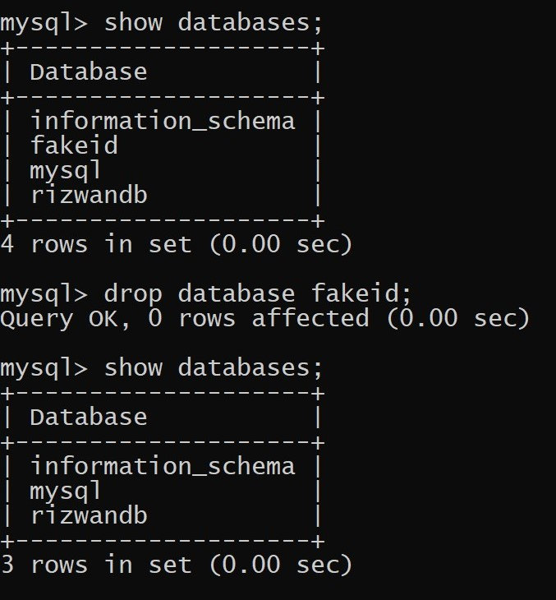

**DML COMMANDS ( Data Modification Language) :**

**Insert :**

**mysql> insert into rizwantable values(2,'rockzz','299',9177276546,'1000 oak california',9.10);**

**mysql> insert into rizwantable (sno,roll,cgpa) values(3,'1A1299',9.38);**

**mysql> select * from rizwantable;**

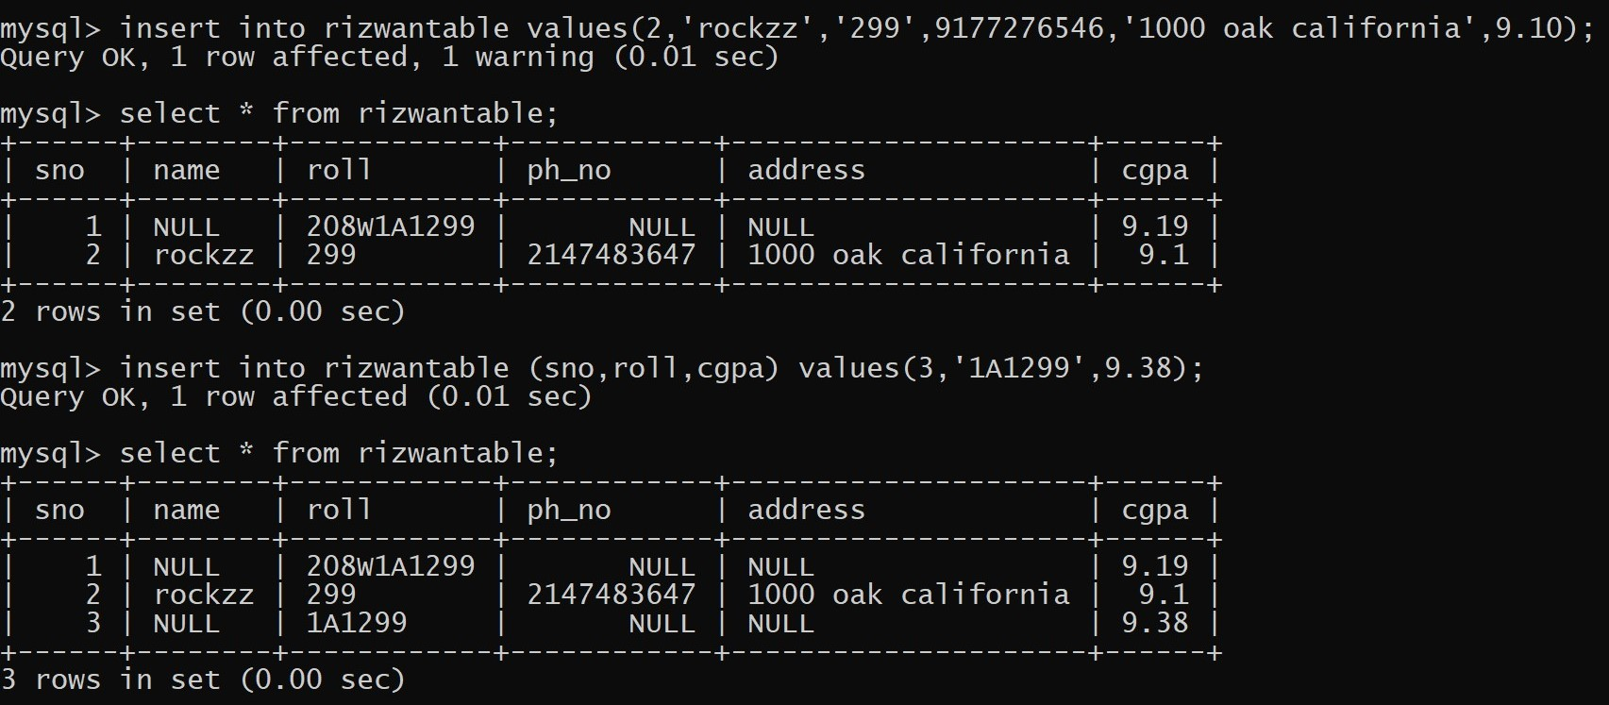

**Update :**

**mysql> update student set roll=1;**

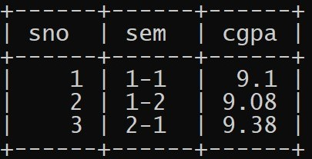

**mysql> update student set sno=2,sem='2-2',cgpa=9.19;**

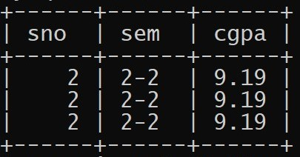

**Delete :**

**mysql> delete from student;**

**mysql> delete table student;**

